

Programme Name: ________**BCS HONS**_______________________________________

Course Code: __**CSC 2730**_______

Course Name: ________**Network And Data Security**______________________________

**Internal Examination**

Date of Submission: ______**1/21/2021**_____________

**Submitted By: Submitted To:**

Student Name**: Dipesh Tha Shrestha** Faculty Name**: Manoj Gautam**

IUKL ID: **041902900028** Department**: LMS**

Semester**: Third Semester**

Intake**: September 2019**

1. **Perform encryption and decryption using RSA algorithm as shown below for the following.**

**P = 17, Q = 11, E= 7; Plain Text M = 88**

1. **In a public key system using RSA, Bob sent a plain text M=88 to Alice using her public key. What is the generated Cipher text C?**
2. **Alice decrypts using her private key. Show the complete working process how to find the plaintext M?**

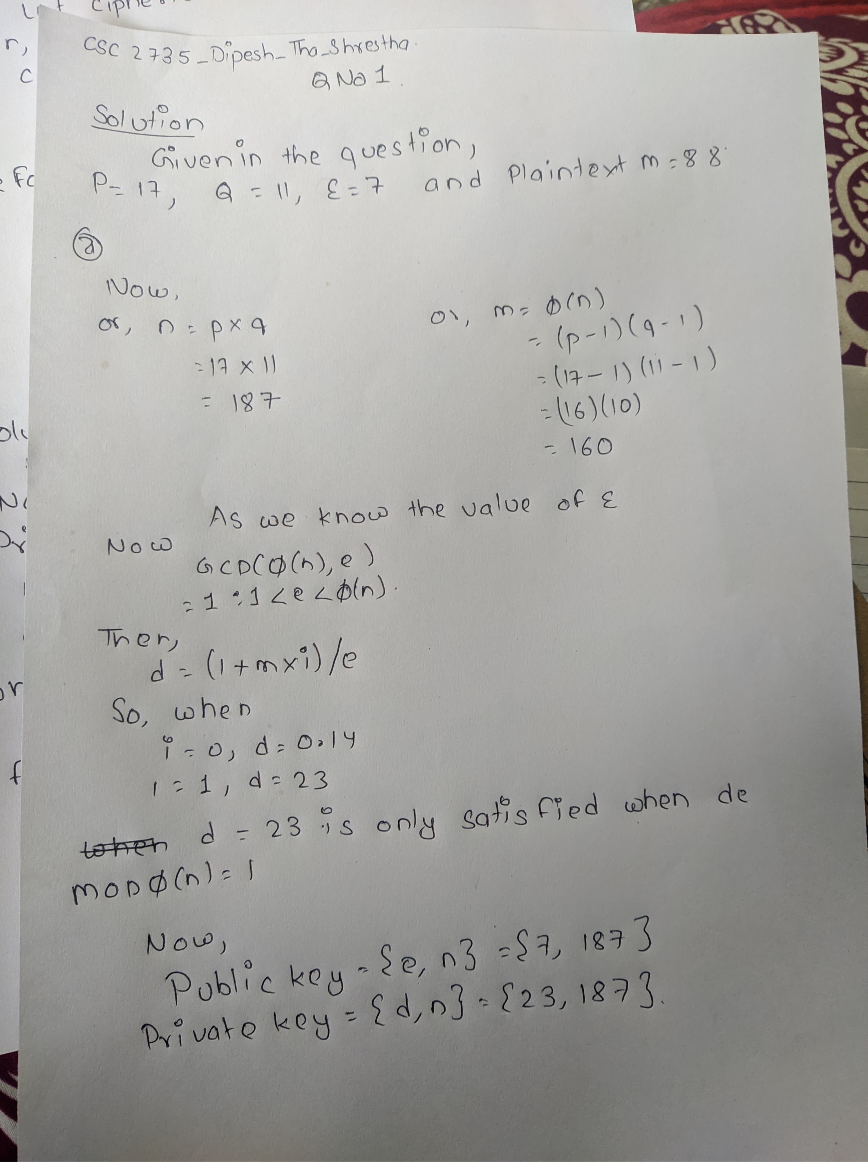

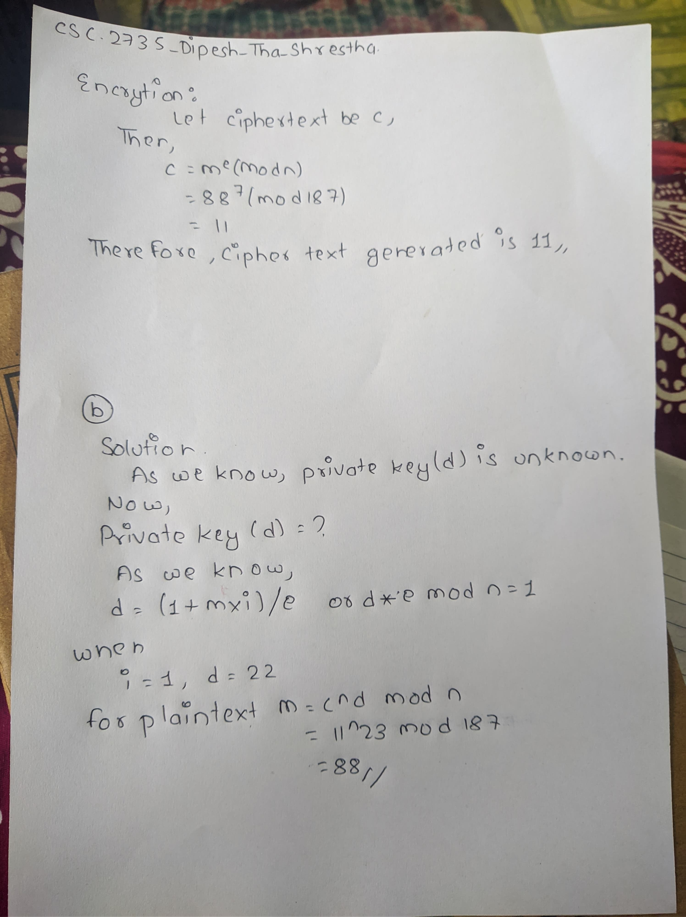

1. **Robert runs a large website that allows users to log in and share images. When a new user sets up their account, the website hashes their password with SHA256 and stores the hash in a database. When a user logs in, the website hashes the supplied password with SHA265 and compares it to the stored hash. Robert figures that with this scheme, if anyone hacks into his database, they will only see hashes and won't learn the user’s passwords. Out of curiosity, Robert does a Google search on several hashes in the database and is alarmed to find that, for a few of them, the google search results reveal the corresponding password.**
2. **What is the risk that it introduces and how many of Robert's users could be affected?**

**Answer**; The risk that it introduces is in this case passwords are stored with outdated irreversible cryptographic functions (SHA256,SHA265). As all password are frequently used and are among the most used password, also these both passwords are of same hash so they do not have a notion of randomness. Therefore, the risk it shows, is it is possible to retrieve all hashes directly by queries in a search engine except for the users who has a complex password. If the hashes are not found directly in google, the attacker has other methods such as, Brute force, Dictionary, Rainbow table, Benchmark to retrieve Md5 password, Improving SHA512, Inappropriate hash function, etc.

1. **How should Robert store passwords?**

**Answer:** Robert should store the password by adding some salt to them. A salt is a random data that concatenated with your password before sending it as the input of the hashing function. For example, if your password is abc and the salt is Sunway@12020, the result of hash Function(‘abc!Sunway@12020’) will be stored in the database instead of hash Function(‘abc’). Hence the rainbow table attacks won’t be effective now as the probability that rainbow table contains hash of ‘abc!Sunwway@12020’ is meager (because generally rainbow tables are constructed from common wordwords, dictionary words etc)

1. **One time pad ciphers are devised by Gilbert Vernam for AT&T. Encrypt the plaintext below using the Vernam cipher technique and given random number. Write your calculation**

**Plaintext: BLANK**

**Random Number: 34, 21 83, 55, 92**

**Numeric equivalent of letters A-z is 0 to 25.**

